演算法實作 班級：_____ 座號：____ 姓名：________

* 請問你平常最喜歡上什麼科目老師的課：(科目)__________/(老師)___________
* 回想/觀察一下平常這位老師上課的時候都如何進行(可以最近一天上的內容舉例)：

例如：上國文課的時候會先上什麼東西以後再上什麼?/英文課上新單元的時候一定會先上什麼?/自然課時什麼主題的課程會先去做實驗?等等

____________________________________________________________________________________________________________________________________________________________________

* 請用條列式編號的方式列出上方這位老師是如何運行上課的：(請列舉至多10件)

1. _____________________________________________________________________
2. ______________________________________________________________________
3. ______________________________________________________________________
4. ______________________________________________________________________
5. ______________________________________________________________________
6. ______________________________________________________________________
7. ______________________________________________________________________
8. ______________________________________________________________________
9. ______________________________________________________________________
10. ______________________________________________________________________

演算法實作 班級：_____ 座號：____ 姓名：________

* 請利用以下符號試著將前一頁事情繪製成流程圖：

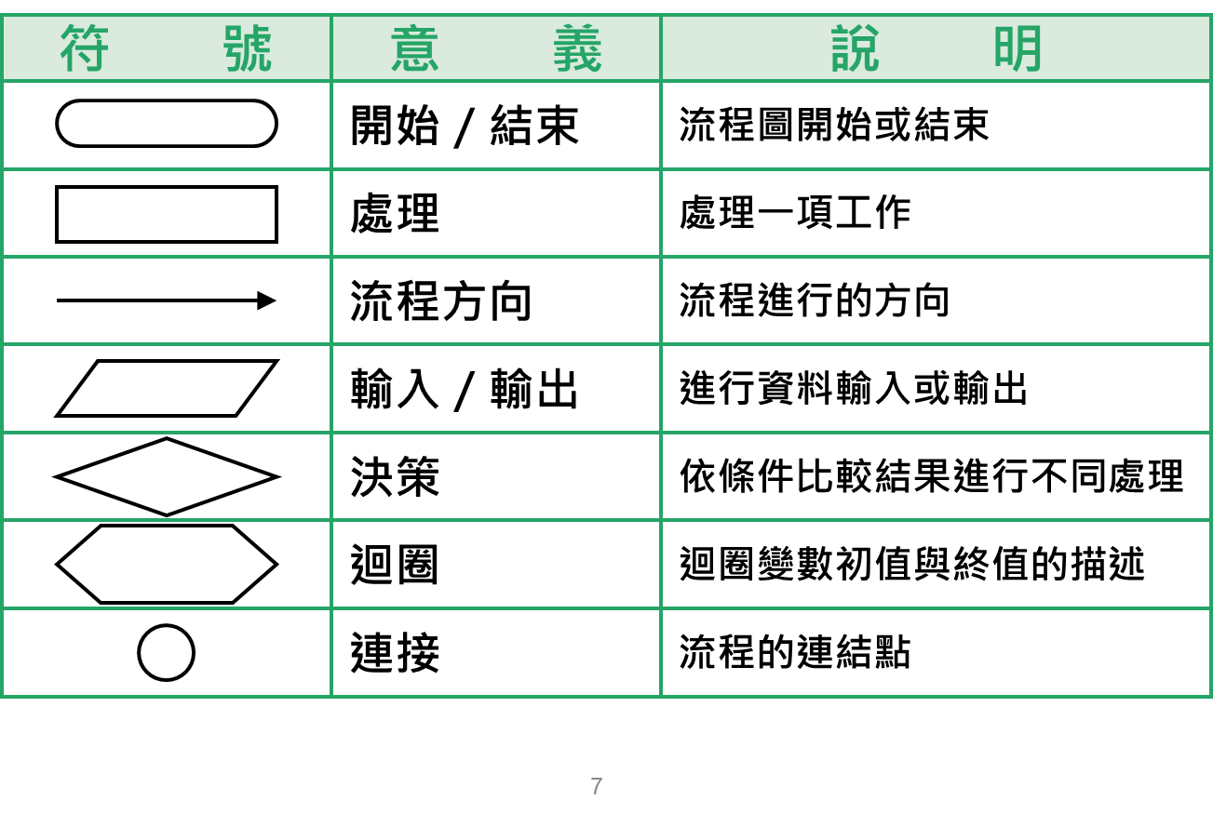

(請畫在框內，並注意繪畫大小)